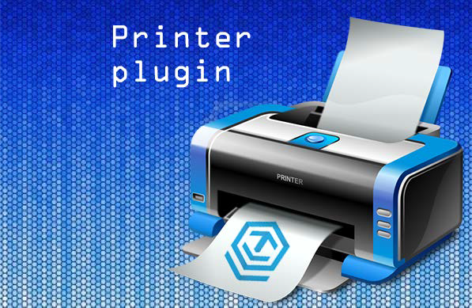

Printer plugin for Unity3D.

***Version 1.03 - Updated 17 June 2014*** *Mac OS X printing added (beta)* ***TEST Version 1.02 - Updated 26 February 2014***

***I changeddadadad***

*- Windows OpenGL support added*

***Version 1.01 – Released 23 May 2013***

# Introduction

Printer plugin allow you send textures from Unity to your printer with various options. Great for interactive kiosks and other installations, where you need something printed.

The asset package consists of the following files:

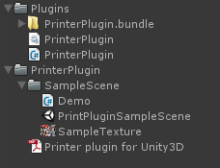

* Plugins

PrinterPlugin.dll – Main plugin DLL (Windows) PrinterPlugin.bundle – OSX bundle PrinterPlugin.cs – plugin static class

* SampleScene

Demo.cs – A sample c# script. PrintPluginSampleScene.unity – A sample demo scene. SampleTexture.png – A sample texture.

# Installation

## Requirements:

* + Unity Pro 3.5 and above
  + Plugin only supports Microsoft Windows and Mac OS X (beta)
  + Windows XP SP3 and higher, Mac OSX 10.9 and higher
  + dadadwdawda

## Installation steps:

1. Import the unitypackage file into your Unity project.
2. Move the “Plugins” folder into the root of your project.

# How to use

## Prepare texture for printing

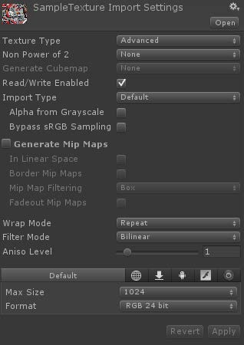

**Texture MUST be uncompressed 24bit or 32bit and read/write enabled! Check sample c# file for usage help.**

Current version function available:

## PrinterPlugin.print(texture,true,PrinterPlugin.PrintScaleMode.FILL_PAGE);

Where:

* texture – Pointer to texture to print.
* showDialog - Boolean value for Print dialog popup.
* printScaleMode – int value for setting texture scale on printed page.
  + 0 – NO_SCALE
  + 1 – SCALE_WIDTH
  + 2 – SCALE_HEIGHT
  + 3 – FILL_PAGE

## Sample usage:

using UnityEngine;

using System.Collections;

public class Demo : MonoBehaviour { public Texture2D texture;

// Use this for initialization void Start () {

//PrinterPlugin.Test();

}

void OnGUI () {

// Make a background box

GUI.Box(new Rect(10,10,220,90), "Printer Menu");

// Make the first button.

if(GUI.Button(new Rect(20,40,200,25), "Print with printer dialog")) { PrinterPlugin.print(texture,true,PrinterPlugin.PrintScaleMode.FILL_PAGE);

}

// Make the second button.

if(GUI.Button(new Rect(20,70,200,25), "Print without printer dialog")) { PrinterPlugin.print(texture,false,PrinterPlugin.PrintScaleMode.FILL_PAGE);

}

}

Support

If you are in need of support or have any comments/suggestions regarding this product please contact us.

Website: [http://www.cleoag.ru](http://www.cleoag.ru/)

Email: [cleoag@gmail.com](mailto:cleoag@gmail.com)

If you are reporting a bug please include any relevant files so that we may remedy the problem as fast as possible.